

Master of Science in Data Analytics
“Dataset of FireBrigadeAndAmbulanceCallOuts”

Submitted by
Mohanraj Jayakumar - 10577457

Supervised by
Prof. Paul Laird
ACKNOWLEDGEMENT

In the process of better understanding of python, the course module B9DA100 Programming for Data Analysis, Processing and Visualisation helped in many ways to know more about the functionalities and usage in day-to-day life. And his class notes are more evident for preparing for our assignment. And the way he teaches the program was more advantageous to decode the problems easily and confidently.

CONTENTS

S.No |  | Description | Pg.No
1. |  | Introduction
 | 1.1 | Source of The Dataset
 | 1.2 | System Requirements
2. |  | Relational Database Modelling
3. |  | Technical Design
 | 3.1 | ETL Architecture
 | 3.2 | Panda’s Operations
4. |  | Testing
5. |  | Learning Outcomes
6. |  | Bibliography

1. INTRODUCTION
This document is evident that the ETL processing in python has successfully transformed and implemented using the given packages and the data are cleaned up with the help said functions and finally the table has been loaded to the SQL Server by transferring the data and resulted in getting a new database. After these executions, the scope of the document is satisfied.
1.1 SOURCE OF THE DATASET
The dataset of this project was given by our professor with some of the changes to the original data. The dataset we used is about the counties in Ireland which involves the activities happens during a fire emergency. The columns and rows denote the activities during the cause.
(council, n.d.)
1.2 SYSTEM REQUIREMENTS
- Visual Studio 2019
- Microsoft SQL Server Management Studio
2. RELATIONAL DATABASE MODELLING
Relational database warehousing is used to create a network between the files can be visualised in the new format. The columns which are used to save and store the values. Creation and insertion of database has been created using the queries and codes in both platforms.
Date | Station Area | Description | TOC | ORD | MOB | IA | LS | AH | MAV | CD

#Creating database and connecting database with visual studio
create_db = ('create database "10577457"')
cursor = connection.cursor()
cursor.execute(create_db)

db_nm = str(10577457)
connection = pypyodbc.connect('DRIVER={ODBC Driver 17 for SQL Server};SERVER=LAPTOP-NAGLDO2B;DATABASE='+ db_nm +';Trusted_Connection=yes;')
cursor = connection.cursor()

create_cmd = ('create table callOuts(Date date,"Station Area" varchar(50),Description text,TOC time,ORD time,MOB time,IA time,LS time,AH time,MAV time,CD time);')
cursor.execute(create_cmd)

for i,r in callOut_csv.iterrows():
insert_q = ("insert into callOuts(Date,[Station Area],Description,TOC,ORD,MOB,IA,LS,AH,MAV,CD) values(?,?,?,?,?,?,?,?,?,?,?)")
v = [r.Date,r[1],r.Description,r.TOC,r.ORD,r.MOB,r.IA,r.LS,r.AH,r.MAV,r.CD]
cursor.execute(insert_q,v)
connection.commit()
connection.close()

3. TECHNICAL DESIGN
A warehouse can be connected using the child packages and subordinately it is managed by the master package by database server. Master package is helpful in running the functioning the respective cells or tables individually. ” It is extremely important to implement a well-designed ETL architecture for an organization’s workload, otherwise, it might lead to performance degradations along with other challenges”. (Das, November 17, 2020)

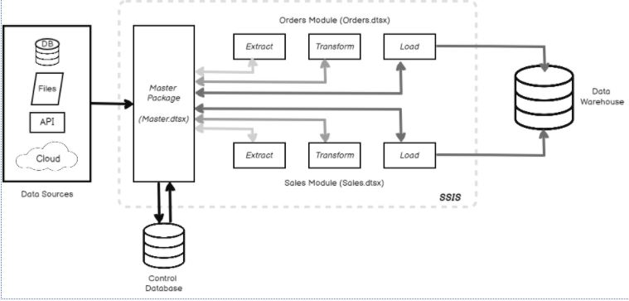
ETL Architecture
3.1 ETL ARCHITECTURE UNDERSTANDINGS
ETL is the process of creating a warehouse using the given data. Initially it extracts the data from the database or from any other sources we choose and transform data from unstructured to structured data and finally it helps to load the data in the required formats.
For ETL process we must import packages to connect the relation between the dataset, this helps in maintaining a standard flow of building the warehouse process. Importing packages is required to be done in all platforms to connect the network or link to the tables we are going to use.
The early stage to commence the process
#ADDING PACKAGES TO CONNECT THE SERVER
connection = pypyodbc.connect('DRIVER={ODBC Driver 17 for SQL Server};SERVER=LAPTOP-NAGLDO2B;DATABASE=master;Trusted_Connection=yes;',autocommit = True)

3.2 PANDAS OPERATION
In our project we are installing numerous packages to load the files for supporting all the datatype. (Pandas, n.d.)

#Importing Packages
import pandas as pd
import io
import datetime
import numpy as np
import pypyodbc

# 1.Load the CSV as Pandas Dataframe and parse date column as per Datetime Format
callOut_csv = pd.read_csv(r'C:\Users\Mohanraj\OneDrive\Desktop\paul CA2 assignment\FireBrigadeAndAmbulanceCallOuts.csv')

I have also implemented some other library functions to elaborate the file in understanding formats, so that the file can be easily visualised in the concerned way. The usage of “describe” function and “info” function for any python dataframe will be useful to lookup the data. These two functions are commonly used for any dataframes.

#Describing the file
callOut_csv.describe()

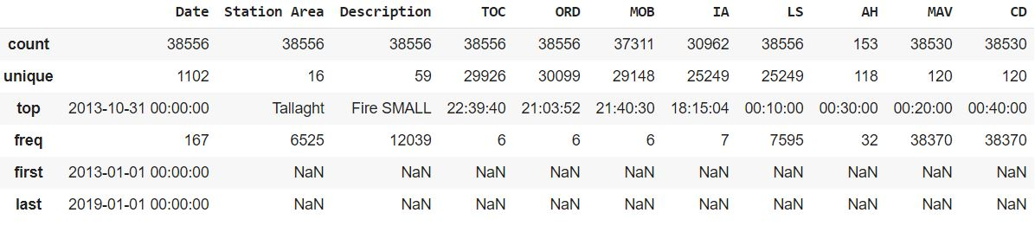

#Displaying the info of the file
callOut_csv.info()

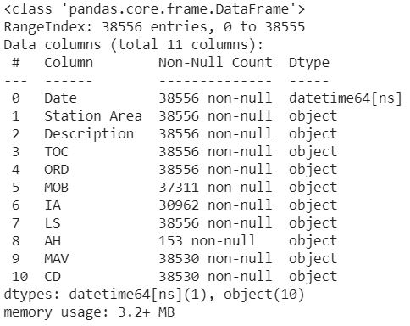

The “shape” function is used to find the length of the rows and columns.
# 2.Getting Shape of the Dataframe(rows, columns) as array
df_shape = callOut_csv.shape
print('Number of Rows: ', df_shape[0], '\nNumber of Columns: ', df_shape[1])

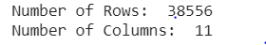

The “notna” function is used to output the number of non-null rows
# 3.The number of non-null rows (by column)
print('Number of Non-Null rows',callOut_csv.notna().sum())

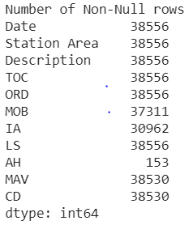

The “isna” function is used to output the number of null values
# 4.The number of null values (by column)
print('Number of Null rows',callOut_csv.isna().sum())

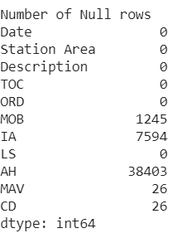

The “isna” function is used to output the number of null values for all columns
# 5.The number of null values for all columns
print('Number of Null rows in all columns',callOut_csv.isna().sum().sum())

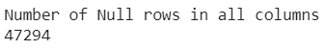

The “value_counts” function is used to output the total number of call outs by Station Area
# 6.The total number of call outs by Station Area
print('Total number of call outs by Station Area',callOut_csv['Station Area'].value_counts())
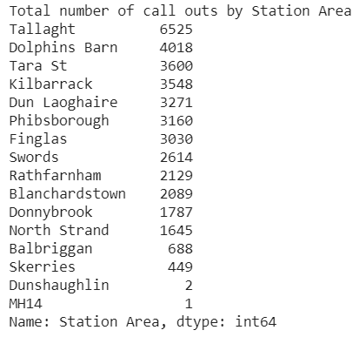

The “groupby” function is used to output the total number of call outs by date and Station Area individually
# 7.The total number of call outs by Date and Station Area
callout_date_desc = callOut_csv.groupby(['Date', 'Station Area']).size()
callout_date_desc_df = pd.DataFrame(callout_date_desc)
callout_date_desc_df.head(20)
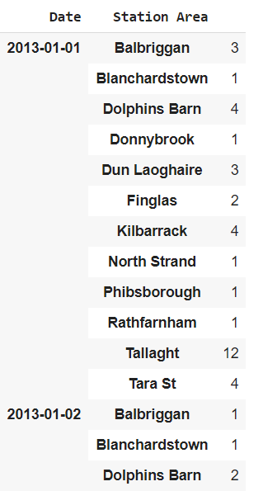

The “groupby” function is used to output the total number of call outs by Station Area and date to identify the description whether its fire car or fire alarm
# 8.The total number of call outs by Station Area and Date where the description is either Fire Car or Fire Alarm
callOut_csv_1 = callOut_csv[callOut_csv.Description.isin(["Fire CAR", "Fire ALARM"])]
callout_date_desc1 = callOut_csv_1.groupby(['Station Area', 'Date','Description']).size()
callout_date_desc_df1 = pd.DataFrame(callout_date_desc1)
callout_date_desc_df1.head(30)
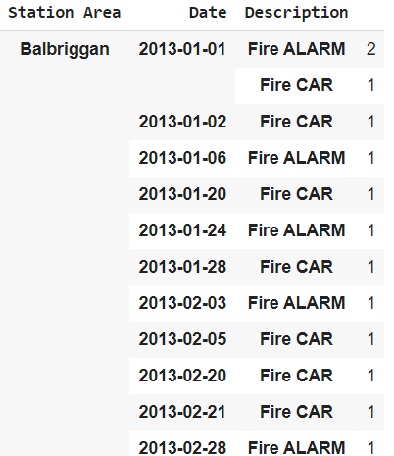

The “replace” function is used to replace the ” , “ values where the values are filled with special characters and those cells are changes to null values.
# 9.Replacing any instance of “,” (in any column) with an empty string
callOut_csv.replace(',', np.nan, inplace=True)
print(callOut_csv)

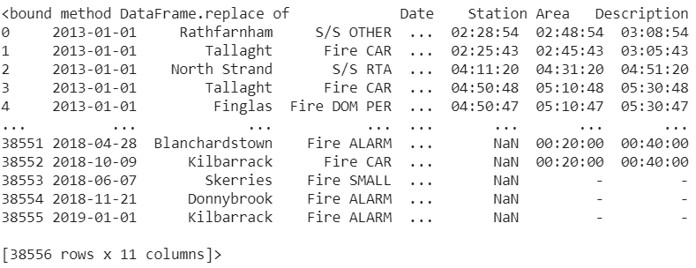

The “replace” function is used to replace the ” - “ values where the values are filled with special characters and those cells are changes to null values. If the values are in the last of the tables, we can use the function called “tail” to lookup the last cells for verification.
# 10.Replacing any instance of “-” (in any column) with an empty string
callOut_csv.replace('-', np.nan, inplace=True)
print(callOut_csv)

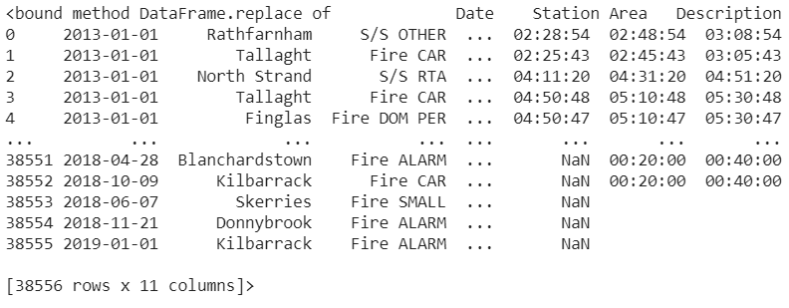

The “notna” function is used to drop the required values

# 11.Drop rows for the columns (AH, MAV, CD) where at least one row value is NULL
callOut_csv.dropna(subset=['AH', 'MAV', 'CD'], axis = 0, inplace = True)
callOut_csv.info()

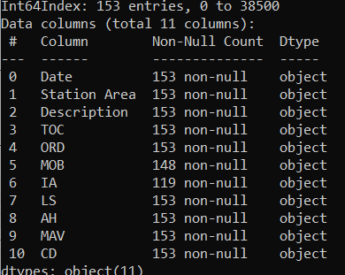

The “drop_duplicates” function is used to drop the required values
# 12.Drop any duplicate rows (except for the first occurrence)
callOut_csv.drop_duplicates(keep = 'first', inplace = True)
callOut_csv.info()
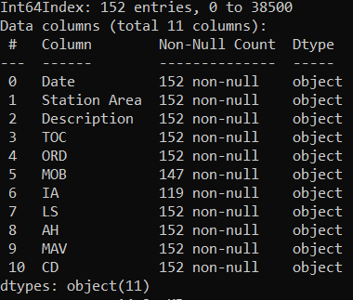

The “difference” function is used to find the minimum difference between the time of two columns and if we need the date we can add on the date function to give with date and time, as our needs are to find only time difference, hence this has been codded only to get time
# 13. Finding minimum time difference between TOC and ORD
callOut_csv.one = pd.to_datetime(callOut_csv['TOC'])
callOut_csv.two = pd.to_datetime(callOut_csv['ORD'])
difference = (callOut_csv.two - callOut_csv.one)
print(difference.min())

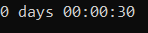
TESTING

4. LEARNING OUTCOMES
In the process of completing the assignments I had a chance of understanding the connectivity link between the python through SQL, by integrating all the steps given in the assignment made me to understand relationship database concepts of ETL architecture and their operations. By applying the pypyodbc (overflow, n.d.) and other packages which helped me in learning the conceptual understanding of libraries in python. Through testing I understood the flow of connection between both the platforms. At the end all this inculcated me to built a structural data warehouse.
- Developed a database using the queries in SQL
- Implemented the structural data using codes to cleansing data
- Performed with multiple packages to import the tables accordingly
- Tested the connectivity between the SQL and Visual Studio 2019 to process the ETL
- Created a database model to understand the ETL operations and performance

BIBLIOGRAPHY
SQL Shack [Online]
Link: https://www.sqlshack.com/designing-a-modular-etl-architecture/

pandas.DataFrame.to_csv [Online]
Link: https://pandas.pydata.org/community/ecosystem.html

Stack Overflow [Online]
Link:https://stackoverflow.com/questions/44520229/connection-string-to-sql-server-with-python-pypyodbc

Moodle [Online]
Link: https://elearning.dbs.ie/mod/page/view.php?id=1013819

Microsoft [Online]
Link:https://docs.microsoft.com/en-us/sql/relational-databases/databases/create-a-database?view=sql-server-ver15

Data.gov.ie [Online]
Link: https://data.gov.ie/dataset/fire-brigade-and-ambulance

